Eldora Processor Upgrade – Task List
Tom Brimeyer
NCAR/EOL – RSF

Overview

The next generation ELDORA radar processor will consist of a single 4u signal processing PC located within the housekeeping rack. The current RP7 signal processor, including rack, will be removed from the system entirely. This transition will require changes to be made in hardware, software, data system, and cabling.

All of the current system functionality will be maintained with the upgrade.

Figure(1) depicts the current configuration of the Eldora Processor and all of its interfaces. Figure(2) depicts the upgraded configuration with the blue highlighting the areas that require change.

The upgrade will consist of the following sections that will be discussed in more detail within this documentation.

- Hardware Changes
- Software Changes
- Cabling Changes
- Signal Processor Data Rate Calculations

All detailed subsections are depicted and can be found in Figure(1) and Figure(2) according to their subsection numbers.

The data format of the new system needs to be determined. In the essence of time, the current data format might need to be maintained.

A more detailed cabling diagram will be provided at a later date.

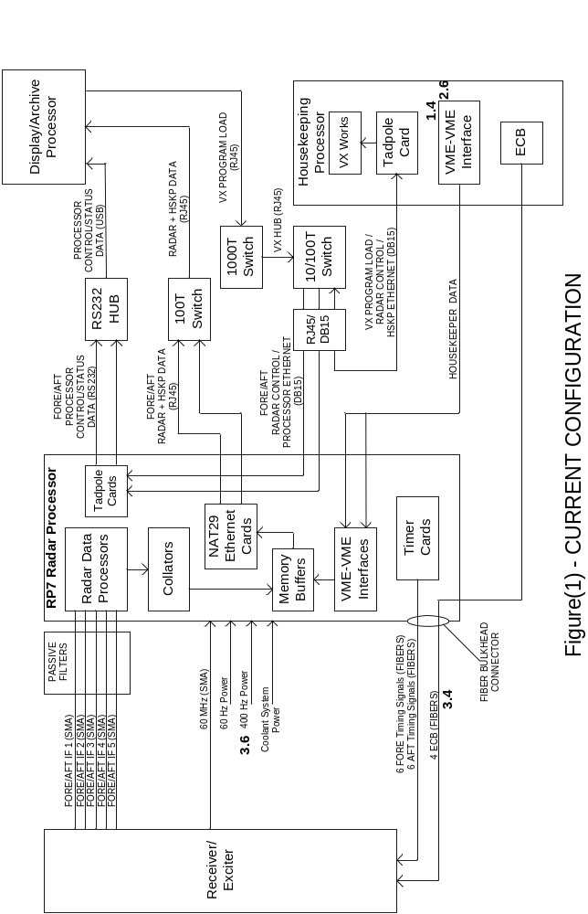
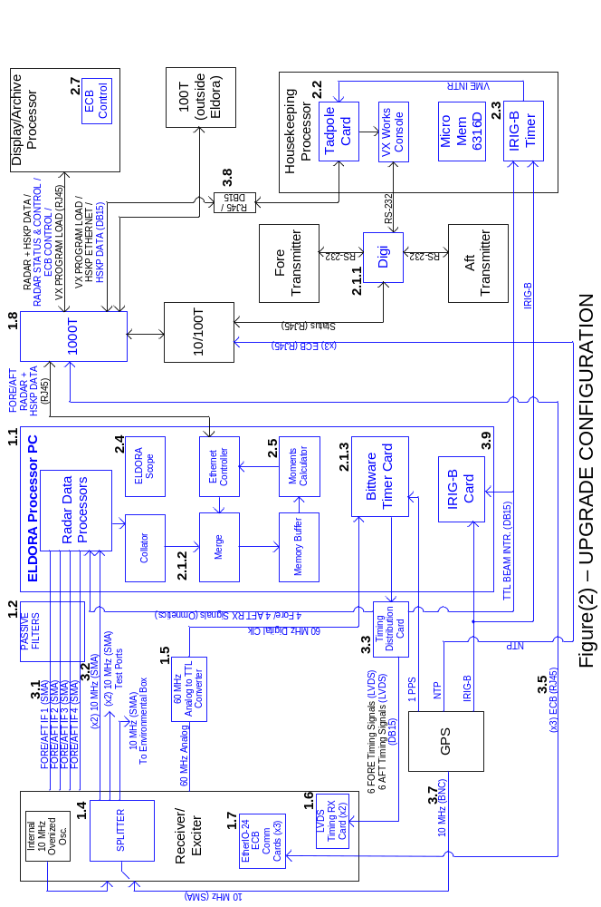
1. Hardware Changes

This section will discuss any changes in the current ELDORA hardware that will need to be made to maintain the functionality of the system.

  - Rack Mount New Processor PC in Housekeeping Rack

The new 4u Signal Processing PC will need to be mounted in the housekeeping rack. A list of cable connections can be found in section 3.

  - Remount Passive IF Filters from RP7 in Housekeeping Rack

There are currently 8 (4 FORE and 4 AFT) IF passive bandpass filters that are located within the RP7 signal processing ack. These filters must be removed and remounted securely within a short distance of the IF inputs of the new Signal Processing PC in the housekeeping rack.

  - Remove VME-VME Bus Connection from RP7 to Housekeeping VME chassis

There is currently 1 VME-VME Interface card in the housekeeper that will no longer be used. This card will be removed entirely or left in the system without functionality. The appropriate software code referring to this interface should be commented out.

  - Install 10 MHz Splitter in Receiver/Exciter Rack

There is currently one 10 MHz SMA source from the Frequency Generator chassis of the receiver/exciter rack. A 5-way splitter and amplifier will need to be mounted inside the Frequency Generation chassis. The internal ovenized 10 MHz oscillator will be routed out of the back of chassis. The external GPS 10 MHz will be routed into the back of the chassis and back out allowing a single cable to be switched between the GPS and ovenized oscillators as needed. Five output SMA ports need to be installed so that the 10 MHz can be routed to the needed areas. One output port will be sent as it currently is, to the Environmental Box. Two other output ports will be sent to the Signal Processing PC in the housekeeping rack. The last two output ports will made available for testing purposes.

  - Convert and Install 60 MHz Analog to Digital Converter

RP7 used a 60 MHz analog to optical converter for the timing system. The optical output will be bypassed and modified to output 60 MHz TTL. This 60 MHz TTL will be the digital clock available to the new Bittware timing card.

  - Build/Install Radar Timing Signal Converter Card in Receiver/Exciter Rack.

There are currently 14 (7 FORE and 7 AFT) optical fiber cables that originate from the RP7 signal processor and terminate into the fore and aft Receiver/Exciters. A summer intern will design a converter board that will accept 12 (6 FORE and 6 AFT) LVDS timing signals from the new Bittware timing card and convert them to TTL. The converter card will then couple the converted TTL signals into the system, bypassing the optical converters.

  - ECB Fiber Replacement

There are currently 4 ECB optical fibers that are responsible for programming various parts of the ELDORA system. The ECB bus will be replaced by a network communication to digital I/O card (EtherIO-24). This upgraded network communication card will use an Ethernet connection to replace the need for the optical fibers. These devices will need to be mounted in place of the current 3 ECB cards located in the fore Receiver/Exciter, aft Receiver/Exciter, and Stepped Attenuator units of the receiver/exciter rack.

  - Upgrade Radar/Housekeeper Data 100T Switch to 1000T

The current configuration uses 2 (1 FORE and 1 AFT) NAT29 VME-Ethernet cards to transfer data from RP7 to a 100T switch and on to the Display/Archive PC. In order to accommodate the possibility of a higher data rate and expandability, a 1000T switch may be needed.

2. Software Changes

This section will discuss any changes in the current ELDORA software that will need to be made to maintain the functionality of the system.

  - Radar Control Software from Control PC

The current configuration uses VxWorks in the housekeeper to communicate control and status information to the fore and aft signal processors and timing generators. Because the new signal processing PC operates under Linux and is no longer compatible with VxWorks, it will be controlled by the Display/Archive PC which also operates under Linux.

    - Radar Processor Control and Status

The current configuration uses the VxWorks OS to control the fore and aft signal processors via an Ethernet connection. It also retrieves status updates via an RS-232 connection. The new signal processors will establish control and status communications solely by an Ethernet connection through a Digi-Port via the Display/Archive PC which also runs Linux.
    - Data Merge and Collate

The current configuration uses VME cards in RP7 to collate, merge, and store the radar and housekeeping data prior to transmitting it to the Display/Archive PC. New software will need to be written that will accept the streaming data from the fore and aft radar processing cards and collate the data as needed. The software will also accept the housekeeping data via Ethernet and merge it with the appropriate radar data on the PCs hard drive prior to transmitting it to the Display/Archive PC. Prior to transmission, the data will reside within the signal processing PC hard drive.

    - Radar Timing Signal Generation

The current configuration uses 2 (1 FORE and 1 AFT) VME timing generation cards to produce the 14 (7 FORE and 7 AFT) pulses to the receiver/exciters. The new signal processing PC uses a new Bittware PCI timing card that will require software to be written in order to program the 12 (6 FORE and 6 AFT) pulses as needed.

  - VxWorks Tadpole VME-Ethernet Control

The current configuration uses VME-VME Interface cards to communicate the housekeeping data to the fore and aft signal processors. Because this is no longer a means of communication, the Tadpole VME-Ethernet card will be used instead. New VxWorks software will need to be written to transmit UDP Hskp Data packets from the Tadpole card to the Processor PC.

  - VME IRIG-B to Create End of Beam Interrupt

The current configuration transmits housekeeper data to RP7 in response to a Beam Interrupt generated by the collator card. In order to maintain functionality, the new PCI timer card will generate a Beam Interrupt signal that will be directly connected to the bc635VME Time and Frequency Processor card. Upon signaling, the bc635VME card will capture time, time stamp the housekeeper data, and produce an interrupt on the housekeeper VME bus that will signal the Tadpole card to send the housekeeper data to the signal processing PC.

  - ELDORA Scope

The current configuration of ELDORA Scope can display a streaming FFT of IQ data for a single IF channel of one, fore or aft, processor. This should be expanded upon so that any of the 8 channels(4 FORE and 4 AFT) can be viewed individually. It should also be able to display A, B, and P data. This will be very useful for testing purposes. This software should reside within the new Signal Processing PC where the radar data will be stored in order to minimize the data bandwidth needed through the 1000T switch to the Display/Archive PC.

  - V, W, Z Moment Calculator

The current configuration calculates the V, W, and Z moments via hardware in RP7. These calculations will now be done via existing in-house moment calculation software that will reside in the Processor PC.

  - Remove VME-VME Interface Software

The current configuration uses software that is responsible for the control of the VME-VME Interface. Once the card is removed from the system, this control software must be removed or commented out of the housekeeper code.

  - ECB Replacement Software

The current configuration uses optical fibers to communicate between the master/slave ECB cards. The current software used to control the bus will need to be removed or commented out. A summer intern wrote a C based library that will be responsible for assuming control and functionality of the ECB bus. This software will reside within the Display/Archive PC.

3. Cabling Changes

This section will discuss any changes in the current ELDORA cabling that will need to be made to maintain the functionality of the system.

  - Make 8 IF Cables from Receiver/Exciter to Signal Processing PC

There are currently 10 IF cables (5 FORE and 5 AFT) with SMA type connectors that run from the receiver/exciters to RP7. There are 2 IF cables (FORE IF5 and AFT IF5) that will not be used and can be removed entirely. There are 8 cables (4 FORE and 4 AFT) that will need to be remade, keeping the same SMA type connectors, to run from the receiver/exciters to the passive IF filters located near the new signal processing PC. The new cables should be made with double shielded coax.

  - Make 60 MHz Cable and (x2) 10 MHz Cables from Receiver/Exciter to Signal Processing PC

The current configuration of RP7 uses a 60 MHz data synchronization signal from the frequency generator of the receiver/exciter rack. The new signal processor requires 2 10 MHz system clock for data synchronization. Two cables must be made to extend from the new 5-way 10 MHz splitter mounted in the receiver/exciter rack to the new signal processing PC located in the housekeeping rack. The 60 MHz cable will be routed from the Receiver/Exciter 60 MHz output to the 60 MHz Analog to Digital Converter.

  - Make Timer Distribution Card from Signal Processing PC to Receiver/Exciter and Housekeeper IRIG-B

There are currently 14 (7 FORE and 7 AFT) fibers that run from the timing card of RP7 to the receiver/exciters. The new Bittware timing card located within the new signal processing PC has a 68-pin SCSI connector that will be routed to a 68-pin SCSI connector of the timing distribution card. There will be two 6 signal cables (6 FORE and 6 AFT) that will run from this card to the receiver/exciters where they will connect to the LVDS to TTL converter card. There will be two 4 signal cables that will run from the timing distribution card to the fore and aft signal processing cards where they will connect by means of Omnetics connectors (PN A29000-115). Another 2 signal cables (TTL) will stem from the timing distribution card and be routed to the bc635VME card of the housekeeper where it will connect to pin-6 of a 15-pin “D” plug and another available for the Processor PC Irig-B timing card.

  - Removed ECB Optical Fibers

There are currently 4 optical fibers that make up the ECB bus which originate in the housekeeper and terminate into the fore Receiver/Exciter unit. These 4 ECB optical fibers are also daisy chained to the aft Receiver/Exciter, Frequency Generator, and Stepped Attenuator units. All ECB optical fibers will be removed.

  - Route ECB Ethernet Cable to Receiver/Exciter

There are currently 4 optical fibers that make up the ECB bus which originate in the housekeeper and are daisy chained to various units of the receiver/exciter rack. There will be 3 Ethernet cables that will be distributed from the 10/100T switch to the 3 EtherIO-24 ECB Ethernet communication cards.

  - Remove Power Cables from RP7

There are currently 3 power cables (400 Hz power, 60 Hz power, coolant system power) that are connected to RP7. These cables will need to be disconnected and tied off or removed as they will no longer be used.

  - Make 10 MHz Cable and Connector from GPS Unit to Receiver/Exciter

In the current configuration, there is no synchronization between GPS and the frequency generator of the receiver/exciter rack. A cable will need to be made that will originate from the GPS unit located in the housekeeping rack and routed to the frequency generator of the receiver/exciter rack. The connection to the GPS is a BNC type connector and the connection to the frequency generator will be an SMA type connector. An SMA connector will need to be installed in the frequency generator to accept the 10 MHz cable and routed to the back of the frequency generator where another SMA connector will serve as a direct output. This will provide 2 10 MHz SMA output connectors (1 GPS and 1 Ovenized Oscillator) at the back of the frequency generator that can be easily switched between.

  - Route Ethernet Cable from Housekeeper to Signal Processing PC via 1000T Switch

The current configuration uses the VME-VME Interface cards to transfer housekeeper data to RP7. The new system will transmit the same data through the 1000T Ethernet switch and on to the new signal processing PC. The network needs to be configured accordingly.

  - New Signal Processing PC Cabling

Once the new signal processing PC is mounted in the housekeeping rack, it will require power, monitor, and mouse cabling. The power cable must provide power to the PC from a 60 Hz power plug strip. A video and mouse splitter should be connected to the existing KVM switch.

4. Data Rate out of Signal Processors

This analysis will be done using the worst case situation of moving the maximum amount of data at the fastest rate.

The following are the worst case assumptions:

Worst Case Staggered PRF = 2000/2500 Hz.
(This will give a worst case "average” PRF of 2250 Hz)

Minimum Time between Dwells = 10.222 ms
(This will allow 5.111 ms PCI access time for both signal processing cards.)

Max Hits per Dwell = 2250 Hz(average PRF) * 10.222 ms(Min Time per Dwell) = 23 Hits per Dwell

Max # of A, B, P Range Gates = 1024

Max # of IQ Range Gates = 20

IQ Data Size = 4 bytes (I = 2 bytes, Q = 2 bytes)
A Data Size = 4 bytes
B Data Size = 4 bytes
P Data Size = 4 bytes

The maximum amount of data is calculated as follows:

Max A, B, P Data = 1024(A,B,P Gates) * 3(data sets A,B,P) * 4 bytes(bytes per data)

= 12288 bytes

= 12 kB of A,B,P data per Dwell per Channel per PRT

Max IQ Data = 20(IQ Gates) * 1(data set IQ) * 23(Hits per Dwell) * 4 bytes(bytes per data)

= 1840 bytes

= 1.8 kB of IQ data per Dwell per Channel per PRT

Max Total Data = 13.8 kB * 2(dual PRT) * 8(total channels)

= 220.8 kB per Dwell / 10.222 ms(Worse Case Time per Dwell)

= 21600 kB per second

= 21.1 MB per second

